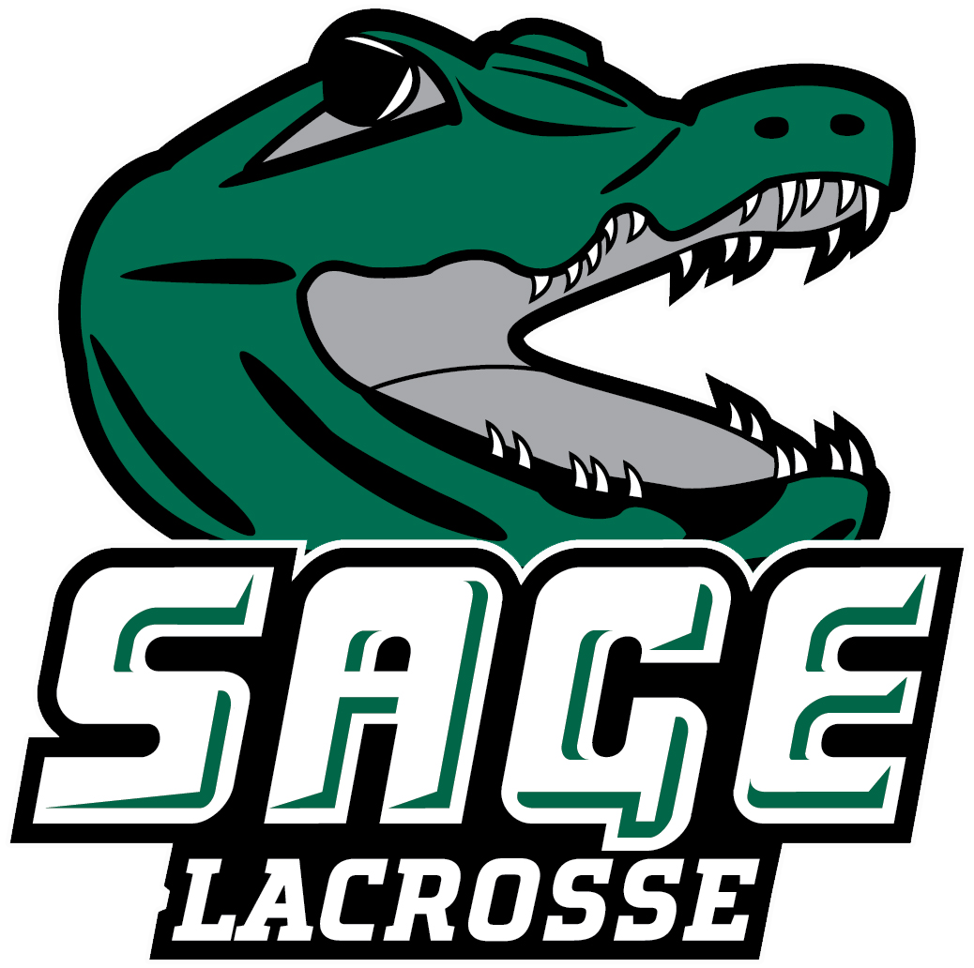

2025 RUSSELL SAGE COLLEGE WOMEN’ S LACROSSE
Office of Athletic Communications 140 New Scotland Avenue • Albany, NY 12208
www.sagegators.com

NO. NAME POS. YR. HT. HOMETOWN/HIGH SCHOOL
1 Aimee Rodriguez A Sr. 5-2 Colonie, NY/Colonie
3 Peggy Monti A Gr. 5-2 Schenectady, NY/Schenectady
4 Paige Stewart A Jr. 5-5 Johnstown, NY/Johnstown
5 Alexis Crossman M So. 5-9 Corinth, NY/Corinth
6 Crystal Ivery D Sr. 5-1 Cairo, NY/Cairo-Durham
8 Samantha Shafer A Gr. 5-6 Schenectady, NY/Schenectady
9 Madisyn Bullock D So. 5-6 Cohoes, NY/Cohoes
10 Samantha Henderson D Fr. 5-6 Hillsdale, NY/Taconic Hills
12 Mackenzie Dahl M Jr. 5-4 Malta, NY/Ballston Spa
14 Emma Friedel A Jr. 5-7 New Hartford, NY/New Hartford
15 Tristyn Valenze M Sr. 5-7 East Greenbush, NY/Columbia
16 Mackenna Huestis D So. 5-5 Gansevoort, NY/South Glens Falls
17 Summer Atchley G So. 5-1 Ballston Spa, NY/Ballston Spa
18 Maia Hunter M Fr. 5-6 Theresa, NY/Indian River
19 Maddison Walter A Sr. 5-2 South Glens Falls, NY/South Glens Falls
20 Elizabeth Zollman A So. 5-6 Bethlehem, NY/Bethlehem
21 Angelina Schaefer D Sr. 5-5 Latham, NY/Shaker
25 Olivia Brand G Fr. 5-7 Little Falls, NY/Little Falls

Interim Head Coach: Joel Braun
Volunteer Assistant Coaches: Anthony Armao, Kevin Lance
Captains: #5 Alexis Crossman, #19 Maddison Walter, and #21 Angelina Schaefer

Pronunciation Guide:
3 Mon-tee
14 Free-del
15 Trist-in Vah-lens-E
16 Hues-tis

April 18, 2025

