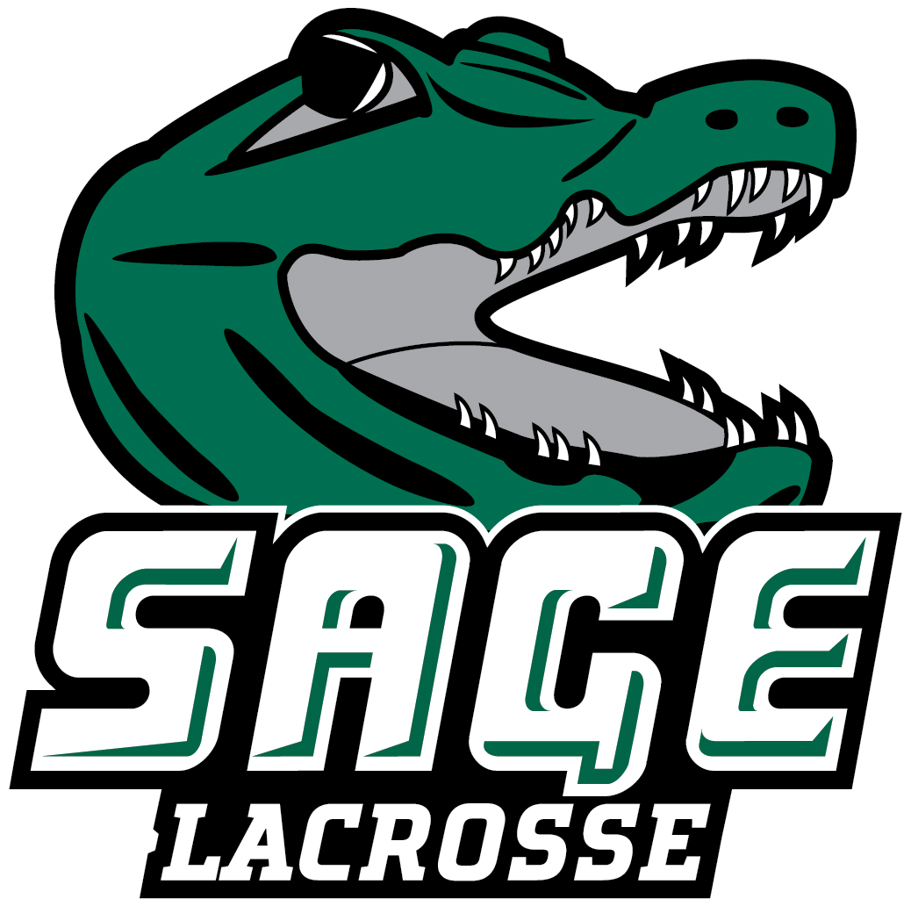

2023 RUSSELL SAGE COLLEGE WOMEN’ S LACROSSE
Office of Athletic Communications 140 New Scotland Avenue • Albany, NY 12208
www.sagegators.com

NO. NAME POS. YR. HT. HOMETOWN/HIGH SCHOOL
2 Emma Hanley MF Fr. 5-3 Ghent, NY/Hudson
3 Peggy Monti D Jr. 5-2 Schenectady, NY/Schenectady
4 Maddy Walter M So. 5-2 Moreau, NY/South Glens Falls
6 Caroline Musinski M Sr. 5-1 Bennington, VT/Mt. Anthony Union
8 Samantha Shafer A Sr. 5-6 Schenectady, NY/Schenectady
9 Shaye Gardinier D Sr. 5-3 New Hartford, NY/New Hartford
11 Marissa Key M Jr. 5-1 Monroe, NY/Monroe-Woodbury
12 Alexandra Queeney A Jr. 5-5 Johnstown, NY/Johnstown
13 Ashley Hearn M Jr. 5-6 Waterloo, NY/Waterloo
14 Brylee Pelfrey D Gr. 5-3 New Hampton, NY/Minisink Valley
15 Grace Hines A Jr. 5-7 Schenectady, NY/Guilderland
17 Mia Unverzagt D Sr. 5-4 Ellenville, NY/Ellenville
21 Angelina Schaefer D So. 5-5 Latham, NY/Shaker
23 Madalynn Walsh GK So. 5-7 Latham, NY/Shaker

Head Coach: Rob Bray (SUNY Potsdam ’91, First Season)
Assistant Coach: Corinne Johnson

Updated: April 11, 2023

