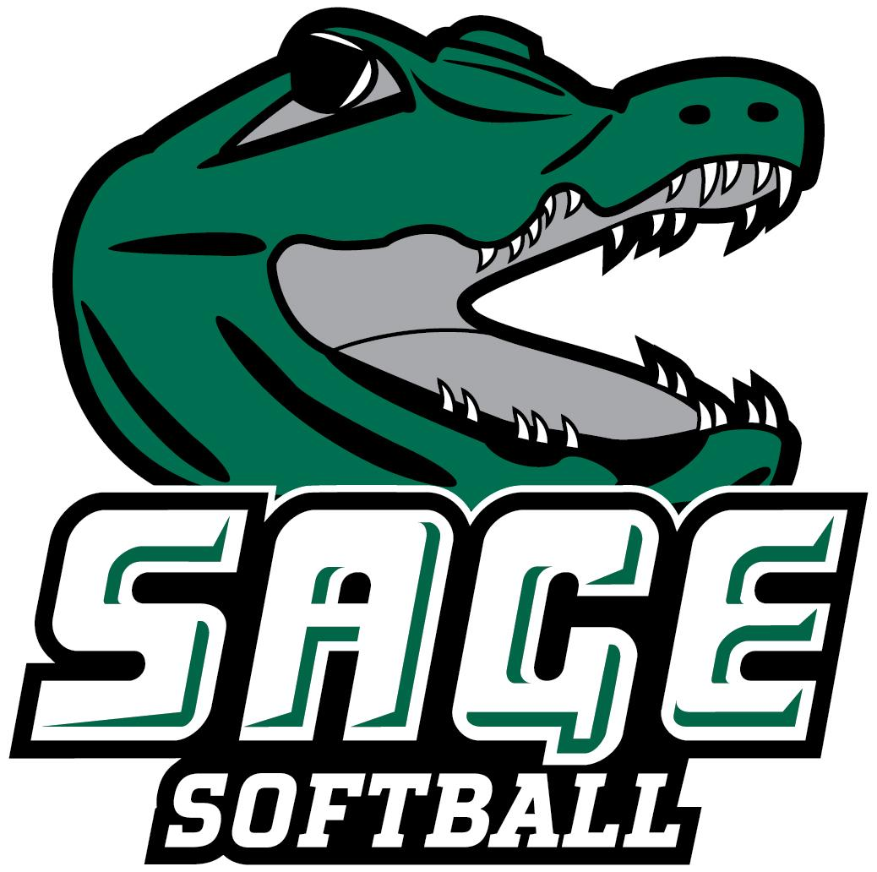

2022 RUSSELL SAGE COLLEGE SOFTBALL ROSTER
# Name Pos. B/T Yr. Ht. Hometown/High School
1 Madalyn Ring OF L/R Fr. 5-0 Gansevoort, NY/South Glens Falls
2 Isabella Vano OF R/R So. 5-4 Yorktown Heights, NY/Yorktown
3 Erika Markowski C/IF R/R Jr. 5-5 Clifton Park, NY/Shenendehowa
4 Arianna Papas OF L/L Sr. 5-7 Castleton, NY/Maple Hill
5 Emma Anderson P/IF R/R Fr. 5-2 Tolland, CT/Tolland
6 Lauren Salmonese OF R/R Jr. 5-8 Poughkeepsie, NY/Poughkeepsie
7 Alanna Dumas C/IF R/R Fr. 5-4 North Bangor, NY/Franklin Academy
8 Ashley Pulcher OF R/R Gr. 5-7 Stuyvesant, NY/Ichabod Crane
9 Amelia Wasilko C/IF R/R So. 5-7 Poughkeepsie, NY/Roy C. Ketcham
10 Ryenne Relyea OF R/R Fr. 5-6 Schenectady, NY/ND Bishop Gibbons
11 Samantha Larsen IF R/R So. 5-8 Mount Marion, NY/Saugerties
13 Makayla Lindsey P/IF R/R Jr. 5-5 New Fairfield, CT/New Fairfield
15 Emily Agate IF R/R Gr. 5-9 Franklin Square, NY/H. Frank Carey
16 Kaitlynn Keeley OF R/R Sr. 5-2 Waterbury, CT/Sacred Heart
17 Taylor Dicranian P/IF L/L Sr. 5-3 Bennington, VT/Mt. Anthony Union
18 Alyson Murphy IF R/R So. 5-5 Gill, MA/Turners Falls
19 Katelyn Rice IF R/R Jr. 5-3 Albany, NY/Colonie Central
22 Kadence Schluter P/IF R/R Fr. 5-4 Warwick, NY/Warwick Valley
23 Serina Garmendiz C/IF R/R Fr. 5-3 Pine Bush, NY/Pine Bush

Head Coach: Erica Li (Williams ‘16/Fourth Season)
Assistant Coach: Alana VanDenburg
Captains: #4 Arianna Papas and #17 Taylor Dicranian
Pronunciations:
#2 Van-oh #3 Mar-cow-ski #4 Pop-us #6 Sal-ma-niece
#7 Do-mas #8 Pull-chur #9 Wa-silk-ko #10 Ryan Ray-lee-ah
#15 Ah-git #17 Da-cran-e-ann #22 Sha-loot-er #23 Serena Gar-men-dez

March 25, 2022

