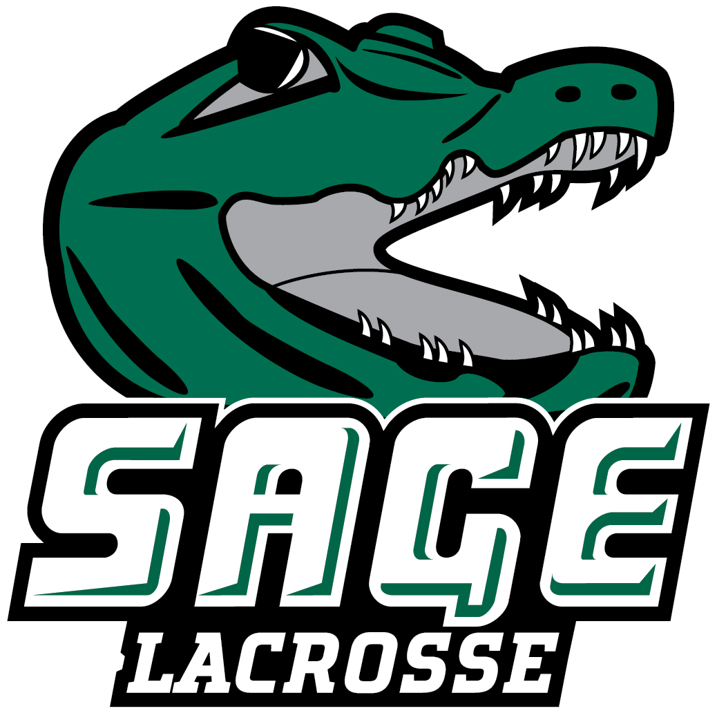

2023 RUSSELL SAGE COLLEGE MEN’ S LACROSSE
Office of Athletic Communications 140 New Scotland Avenue • Albany, NY 12208
www.sagegators.com

NO. NAME POS. YR. HT. WT. HOMETOWN/HIGH SCHOOL
1 Gamo Koulibaly M Fr. 5-10 180 Aurora, CO/Rangeview
2 Joe Johnson D So. 5-8 185 Gansevoort, NY/South Glens Falls
4 Sean McGirr M Sr. 6-0 195 Saugerties, NY/Saugerties
6 Justin Mayo A So. 6-2 235 Clifton Park, NY/Shenendehowa
7 Shea Obado M Gr. 5-11 180 Spotswood, NJ/Spotswood
10 Adam Willig M Jr. 5-11 175 Buffalo, NY/Amherst Central
11 Ryan Hanna M Jr. 5-11 188 Flanders, NJ/Mt. Olive
12 Anthony Abreu A Sr. 5-7 145 Monroe, NJ/Monroe Township
13 Malachi Gamboa M So. 6-2 230 Bronx, NY/Frederick Douglass Academy
14 Kollin Matthews A So. 5-8 145 Marcy, NY/Whitesboro
16 Jared Heineman D So. 5-8 150 Budd Lake, NJ/Mount Olive
17 Zach Cahill A Jr. 6-3 150 Hoosick Falls, NY/Hoosick Falls Central
18 Mat Durkin M Jr. 5-11 175 Plattsburgh, NY/Plattsburgh
19 Erik Reynolds GK So. 6-0 205 South Glens Falls, NY/South Glens Falls
20 Jake McElwee M Jr. 5-7 150 Jackson, NJ/Jackson Liberty
24 Bailey Martin A Gr. 5-5 170 Syracuse, NY/Onondaga Central
27 Anthony Marrone M Jr. 6-0 170 Monroe, NJ/Monroe Township
28 Matthew DeSocio D Fr. 6-0 165 Queensbury, NY/Queensbury
30 Drew Rankin D So. 6-2 225 Painted Post, NY/Corning Painted Post
31 Jonathan Vil M Gr. 6-3 160 Montgomery, NY/Valley Central
33 Nate Kettle A Fr. 5-6 160 Killbuck, NY/Salamanca
34 Angel Castillo D Fr. 5-10 220 Newark, NJ/Eastside
36 Andrew Collora G Fr. 6-2 180 West Babylon, NY/West Babylon
38 Zakary Lesson D Fr. 6-1 235 Stillwater, NY/Stillwater
40 Sebastian Carazo A So. 5-9 200 Urbana, MD/McEachern/LaGrange
41 Mame Diba A Fr. 6-4 190 New York, NY/Haldane
42 Mason Remington D Fr. 6-5 173 Jericho, VT/Mount Mansfield Union
55 Jacob Peck D Sr. 6-4 240 Albany, NY/Guilderland

Head Coach: Ryan Lanigan, Lebanon Valley College ’14 (Fifth Season)
Assistant Coaches: Chris Joyce, Ryan Adamczak, Matt Fisher, Chris Moutopolous, James Pedersen, Colangelo Alesandro
Captains: #2 Joe Johnson, #12 Anthony Abreu, and #20 Jake McElwee
Letterwinners Returning/Lost: 19/10

Updated: March 24, 2023

