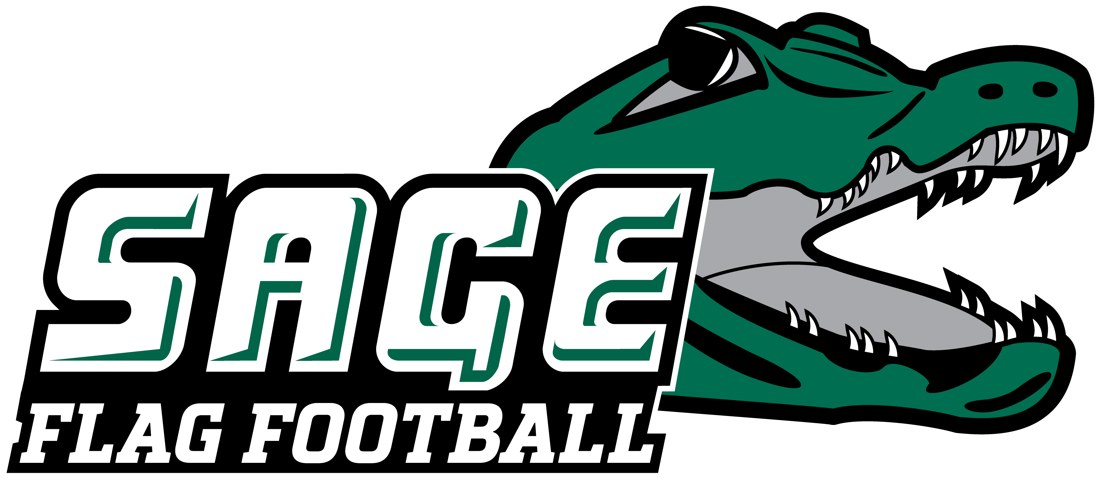


2026 RUSSELL SAGE COLLEGE WOMEN’ S FLAG FOOTBALL

NO. NAME YR. HOMETOWN/HIGH SCHOOL/PREVIOUS SCHOOL
2 Sanai Esquilin So. Brooklyn, NY/John Jay School for Law
3 Kaleigh Dean So. Salt Point, NY/FDR
4 Bianca Ricciuto Jr. Montgomery, NY/Valley Central/SUNY Poly
5 Allie Salvione So. Johnstown, NY/Gloversville/FMCC
6 Lydia Kern So. Williamson, NY/Williamson Central
10 Hailey Blake So. Schenectady, NY/Colonie Central
11 Kaitlyn Phillips Jr. Brooklyn, NY/John Jay School for Law
12 Michelle Espinal Fr. New York, NY/Washington Heights Expeditionary Learning School
13 Cassidy Weiher Jr. Aurora, CO/Cherokee Trail/Southern Maine
14 Isabella Clute Fr. Schenectady, NY/Mohonasen
21 Clara Stodolka Fr. Niskayuna, NY/Niskayuna
24 Aniyah Kelley Sr. New Castle, DE/William Penn
44 Alia Charles So. Brooklyn, NY/John Jay School for Law
85 Jordan Contardo Jr. Cheshire, CT/Cheshire
87 Morgan Potter Sr. Poland, NY/Poland Central

Head Coach: Denver Divens (First Season, SUNY Brockport ‘16)
Assistant Coaches: Sara Doyle and Collin Ellsworth

Pronunciation Guide:
#2 Sa-nye S-quill-lynn
#4 Ra-sue-tow
#13 We-here
#14 Cloot
#21 Sta-dole-ka

March 23, 2026

Office of Athletic Communications 140 New Scotland Avenue • Albany, NY 12208
www.sagegators.com

