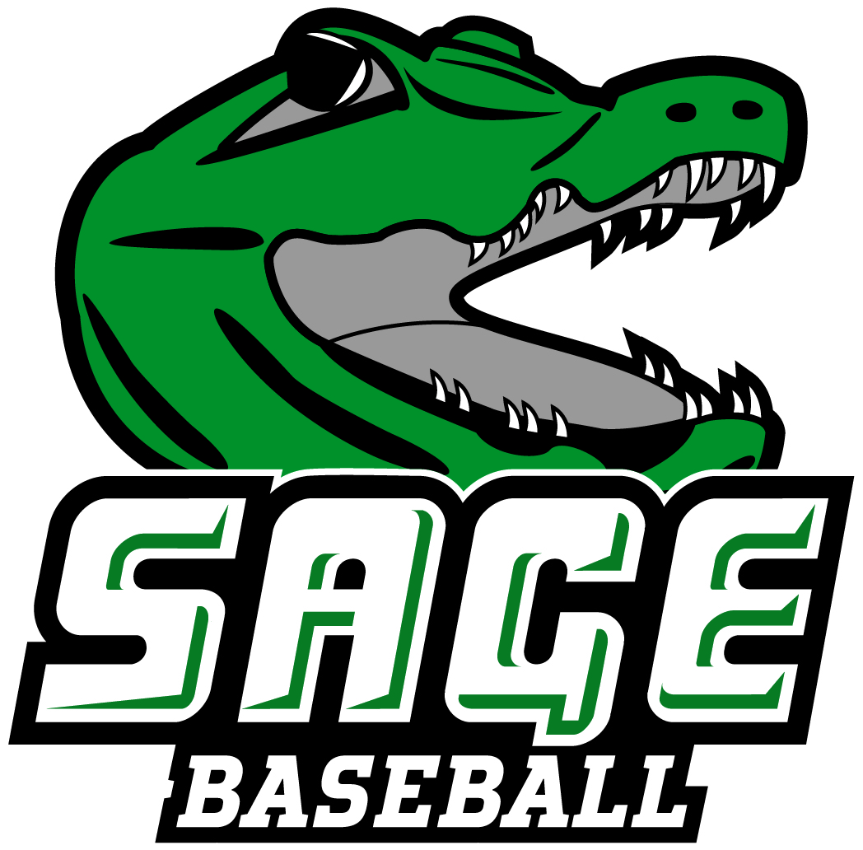2022 RUSSELL SAGE BASEBALL TEAM “THE GATORS”
No. Name Pos. B/T CL. Ht. Wt. Hometown/High School
1 Leandro Guzman OF R/R Fr. 5-9 180 New Britain, CT/New Britain
3 Adonis Cherry OF/P L/L Fr. 6-6 225 Las Vegas, NV/Odyssey Charter
4 Jack Duane OF L/R Fr. 5-5 134 Glenville, NY/Burnt Hills-Ballston Lake
5 Dylan Scherillo P/C R/R Fr. 6-3 218 Drums, PA/New Dorp
6 Jacob Coonan OF L/L Fr. 5-10 165 Wynantskill, NY/Averill Park
7 Jake Milak C R/R Fr. 5-7 195 Santa Clarita, CA/Canyon
8 Frank Colletta 1B R/L Fr. 6-0 190 Holtsville, NY/St. John the Baptist
9 Ryan Smith C R/R Fr. 6-0 150 Washingtonville, NY/Washingtonville
10 Christian Brown 3B R/R Fr. 6-2 245 Troy, NY/Troy
11 Dillon Maxon C R/R Gr. 6-1 225 Troy, NY/Tamarac
12 Sean Berry SS/P R/R So. 6-2 200 Tivoli, NY/Red Hook
13 Brenden Nihill 3B L/R Fr. 6-2 190 Chandler, AZ/Basha
14 Colby Phelps P R/R Fr. 5-10 165 Troy, NY/Tamarac
15 Jack Clifford P/C R/R Fr. 6-2 180 Newburgh, NY/Newburgh Free Academy
16 Griffin Snyder P R/R Fr. 6-3 210 Cheektowaga, NY/St. Joseph’s Collegiate Inst.
17 Liam Doyle P/1B L/R Fr. 5-10 180 West Sayville, NY/Connetquot
18 Will Simkin P R/R Jr. 6-1 215 Canberra, Australia/Canberra Grammar
19 Joe Salerno 2B R/R Fr. 5-8 175 White Plains, NY/White Plains
21 Alex Andrew 1B/OF R/R So. 6-0 200 Port Washington, NY/Paul D. Schreiber
22 Zachary Figueras SS/P R/R Fr. 5-10 175 Apopka, FL/Windermere
23 Diego Jimenez OF R/R Fr. 6-2 185 Monroe, NY/Monroe Woodbury
24 Nick Marsella 2B/SS R/R Fr. 6-1 170 New Hyde Park, NY/New Hyde Park Mem.
26 Richard Illa Acosta P R/R Fr. 6-2 170 New York, NY/All Hallows
28 Jacob Bacenet IF R/R Fr. 5-9 175 Shoreham, NY/Shoreham Wading River
29 Jaylen Cuevas P R/R Fr. 6-0 185 Bronx, NY/Fordham Prep
30 Michael Karpinski P R/R Fr. 5-11 185 Ballston Spa, NY/Saratoga Springs
34 Ethan Basos P R/L Fr. 5-10 280 Wynantskill, NY/Averill Park
35 Jack Armann OF L/L Fr. 5-8 165 Bellport, NY/Bellport
41 Cameron Anderson P R/R Gr. 6-5 200 Clifton Park, NY/Burnt Hills
44 Andrew Knapp 1B L/R Fr. 6-0 240 Nanuet, NY/Nanuet
Head Coach: Nick Pontari, Brockport State ’16 (First Season)
Assistant Coaches: Karl Steffen, George Rafferty, Jack Brock, Michael Branche, and Shawn Gibson
Pronunciation Guide Coaching Staff
- Leandro Guzman Lee On Dro - Goo zmon Nick Pontari Pont tair ee
Karl Steffen Steff- En
- Adonis Cherry Ah don is
5 Dylan Scherillo Sure-ill-Oh
7 Jake Milak Mee-lack 28 Jacob Bacenet Bass-en-ett
13 Brenden Nihill Nye- Hill 29 Jaylen Cuevas Jay-Lynn Quay-vas
22 Zachary Figueras Fi- guer- as 23 Diego Jimenez Himenez 34 Ethan Basos Base-os
Updated 4/12/2022 Office of Athletic Communications 140 New Scotland Avenue • Albany, NY 12208 P) 518.244.4767 F) 518.720.3007
W) www.sagegators.com E) kinga2@sage.edu E) youngk7@sage.edu

